Annual Professional Baseball & Hockey Chiropractic Societies Workshop
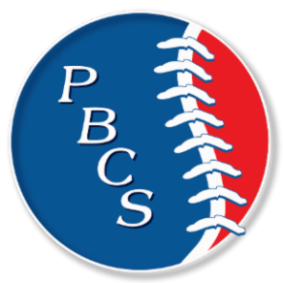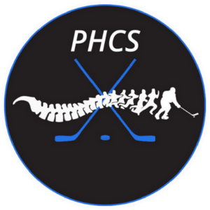
November 17th – 19th, 2022 – Naples Grande Beach Resort, Naples Florida

Outline of Program for 12 hours of Clinical CE
Friday November 18th, 2022
Breakfast: 8:00 a.m. to 8:45

Managing Risk in Sports Chiropractic- Communication and Proper Documentation
Time: 9:00 a.m. to 10:40 a.m.
Speaker: Alan Sokoloff D.C. – Team Chiropractor for the Baltimore Orioles and the Baltimore Ravens

Break: 10:40 a.m. to 11:00 a.m. – Visit with the vendors

Cervical Spine and Subluxation Pattern of the Rotational Athlete
Time: 11:00 a.m. to 11:50 a.m.
Speaker: Shawn Caldwell D.C.- Team Chiropractor for the Colorado Rockies and Denver Nuggets

Lunch: 12:00 p.m. to 1:00 p.m.

Expert Panel
Time: 1:00 p.m. to 2:00 p.m.
Speakers: All Speakers– Ask our speakers & experts the questions you’ve wanted to ask.

Challenges of the 21st Century Athlete – “An Opportunity to Lead” A multi-disciplinary approach to Sports Medicine
Time: 2:00 p.m. to 3:40 p.m.
Speaker: Todd Tomczyk A.T.C.- Director of Sports Medicine for the Pittsburgh Pirates

3:40 p.m. to 4:00 p.m. - Visit with the venders

Dynamic Neuromuscular Stabilization (DNS) in the Rotational Athlete – Part 1
Time: 4:00 p.m. to 4:50 p.m.
Speaker: Brett Winchester D.C.

Saturday, November 19th, 2022

Breakfast: 8:00 a.m. to 8:45

The Continuum of Care - Collaborating Treatment & Performance
Time: 9:00 a.m. to 10:40 a.m.
Speaker: Ken Kaufman D.C. – Chiropractic Consultant with the Pittsburgh Pirates- Spring Training

Break: 10:40 a.m. to 11:00 a.m. – Visit with the vendors

Implementing CBD Topicals in Activation and Recovery Protocols for Athletes
Time: 11:00 a.m. to 11:50 a.m.
Speaker: Matt Krause A.T.,C. – Director of the Professional Baseball Strength & Conditioning Coaches Society

Lunch: 12:00 p.m. to 1:00 p.m.

Awards: 1:00 p.m. to 1:40
PBCS/PHCS Visionary and Lifetime Achievement Awards (and special guests)

Understanding physical limitations in the rotational athlete and how to bring efficiency to the player and the practice
Time: 2:00 p.m. to 3:40 p.m.
Speaker: Sean Drake D.C.

Break: 3:40 p.m. to 4:00 p.m. - Visit with the vendors

Dynamic Neuromuscular Stabilization (DNS) in the Rotational Athlete
Time: 4:00 p.m. to 4:50 p.m.
Speaker: Brett Winchester D.C.

5 p.m. - One last visit with our fabulous sponsor/vendors

